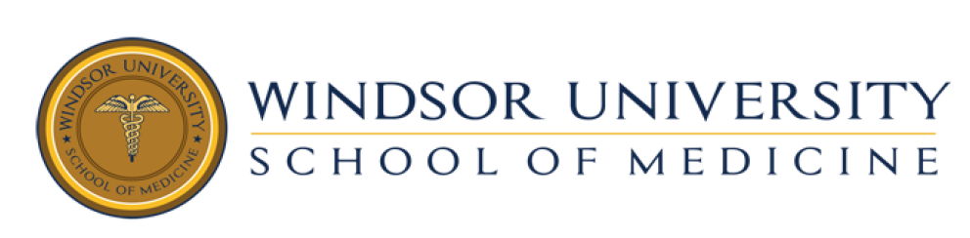
Dear Student:
Dr. Sandeep is conducting a webinar for those interested in information regarding residency. This is not mandatory.

Match 2016:

1. ERAS Applications: Timelines/Token/Deadlines
2. Dean's Letter or MSPE
3. CV, Personal Statement, LOR
4. Interview Process & Matching
5. Networking

Wed, Aug 12, 2015 1:00 PM - 3:00 PM Central Daylight Time
Please join my meeting from your computer, tablet or smartphone.
https://global.gotomeeting.com/join/630199533
You can also dial in using your phone.
United States : +1 (571) 317-3112
Access Code: 630-199-533

